Getting Started With ArgoCD on your Kubernetes Cluster

Pascal Zwikirsch
Follow
Dec 28, 2021 · 8 min read
A step-by-step guide to set up ArgoCD on your Kubernetes cluster and synchronize your resources with your GitHub repository.

Prerequisites
For this tutorial, you need an up and running Kubernetes cluster available. The easiest way is to set up a Vagrant VM with a K3s cluster, as shown in one of my other articles.

Local Kubernetes Development using Vagrant and K3s

A step-by-step guide to set up K3s on your local Vagrant machine, and deploy an application to the cluster from your…
levelup.gitconnected.com

You should check out the GitHub repository I prepared here to follow this tutorial properly, and your ArgoCD definition works out of the box. https://github.com/Abszissex/medium-argocd

GitHub - Abszissex/medium-argocd

You can't perform that action at this time. You signed in with another tab or window. You signed out in another tab or…
github.com

The manifests folder contains all the ArgoCD application resources and the Helm chart we will apply later.
The vagrant folder contains some pre-configured Vagrantfile with automatic setup for a K3s cluster.

ArgoCD setup
After you have confirmed that your cluster is up and running, it's time to set up ArgoCD on it.
First, we have to set up a namespace for ArgoCD to live.
kubectl create namespace argocd
Second, we have to apply a Kubernetes manifest provided by the official ArgoCD documentation that contains several deployment and services resources to make ArgoCD work out of the box.
kubectl apply -n argocd -f https://raw.githubusercontent.com/argoproj/argo-cd/stable/manifests/install.yaml
The spin-up of all the pre-configured ArgoCD resources might take a bit of time, depending on your machine resources, but you can regularly check with the following command if ArgoCD is ready.
kubectl get all -n argocd
When everything is ready, it should look like the following:

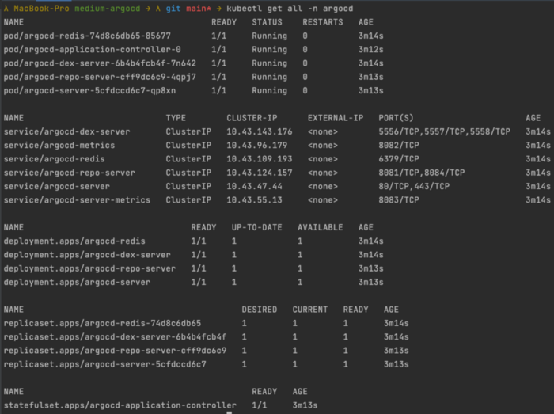
kubectl get all -n argocd

Creating your first ArgoCD application
For ArgoCD to properly manage your Helm charts, you need to create and run an "ArgoCD Application" on your Kubernetes cluster that is in charge of syncing your resources with your provided GitHub repository.
You can find an example at my above mentioned GitHub repository at manifests/argo/argocd-app.yaml or in the below Gist.
Let's examine the most important properties of this YAML file.
- The apiVersion and kind define that this resource should be an ArgoCD Application which is a "Custom Resource Definition" (CRD) provided by ArgoCD
- The spec.destination tells the application where ArgoCD should deploy the synced resources. In our case, it's our own local Kubernetes cluster.
- Via spec.source you can define the destination of the Helm chart, the value files you want to apply, and the repository URL. Be aware that your repository needs to be public in this case. Also, you have to use the HTTPS variant instead of SSH since our ArgoCD application doesn't have any SSH credentials configured yet to authenticate with GitHub.
- Last but not least, the spec.syncPolicy defines how ArgoCD should synchronize the resources. We currently set it to an empty object{} because we want to hit the "synchronize" button manually. But later, I will also show you how to set up the automated synchronization policy, so ArgoCD updates your resources automatically.
You can create this resource using:
kubectl apply -f manifests/argo/argocd-app.yaml

Exposing the ArgoCD UI on your machine
Since we want to hit the "synchronize" button and see our application deployment, we need some GUI. Fortunately, ArgoCD has already installed it on our Kubernetes cluster. The only thing missing to access it is that we expose it via a NodePort service resource.
You can find an example at my above mentioned GitHub repository at manifests/argo/argocd-nodeport.yaml or in the below Gist.
We won't go over each property, but essential for us is the spec.ports definition.
In the definition, you see that we expose the nodePort for the Port 80 (HTTP) on 30007 and 443 (HTTPS) on 30008. This means we can access this service and the behind lying ArgoCD UI on our local machine's ports 30007 and 30008. But due to the local development, you will most likely have no valid SSL certificate anyway, so let's go for the 30007 port. For a production-grade application, I would recommend removing the mapping on Port 80 and only exposing the HTTPS variant.
You can create this resource using:
kubectl apply -f manifests/argo/argocd-nodeport.yaml
Besides applying both scripts individually, you can also apply both at once using:
kubectl apply -f manifests/argo

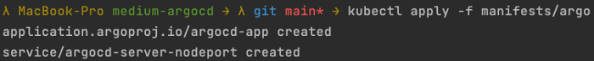
Creating ArgoCD App and Service | `kubectl apply -f manifests/argo`

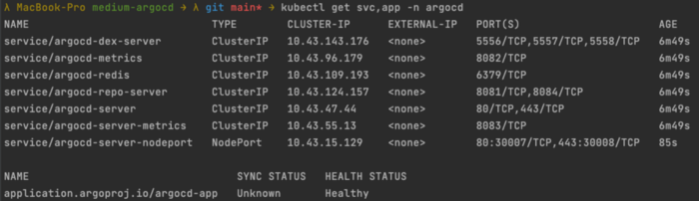
Checking if kubectl has properly deployed ArgoCD App and Service | `kubectl get svc,app -n argocd`

Accessing the ArgoCD UI
After applying the application mentioned above and the service, it's time to access the ArgoCD UI.
You can access the ArgoCD UI by navigating to http://localhost:30007 in your browser. Of course, your browser will warn you that you are trying to access an insecure connection, but this is okay for the demo purpose and the local development.

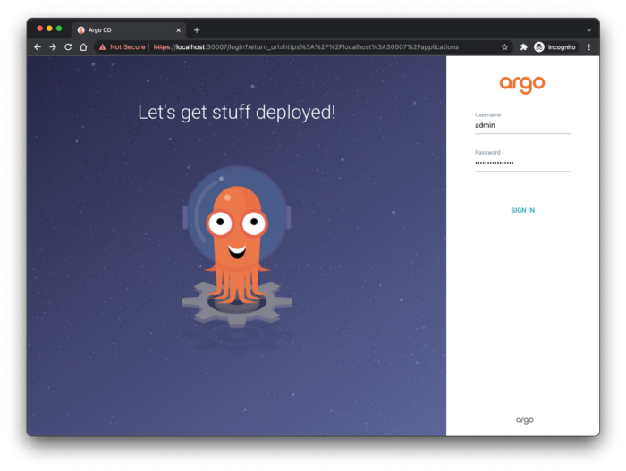
Navigating to the ArgoCD UI on http://localhost:30007
The ArgoCD UI requires authentication. The default user is admin. And the initial automatic-generated password can be received using the following kubectl command. Of course, you can change this later in the UI if you want.
kubectl -n argocd get secret argocd-initial-admin-secret -o jsonpath="{.data.password}" | base64 -d; echo

Synchronizing your resources
After login, the website will redirect you to the applications overview page, where you can already see your previously deployed argocd-app. Also, you see the yellow icons indicating that resources, based on your Helm chart, are missing and are out of sync.

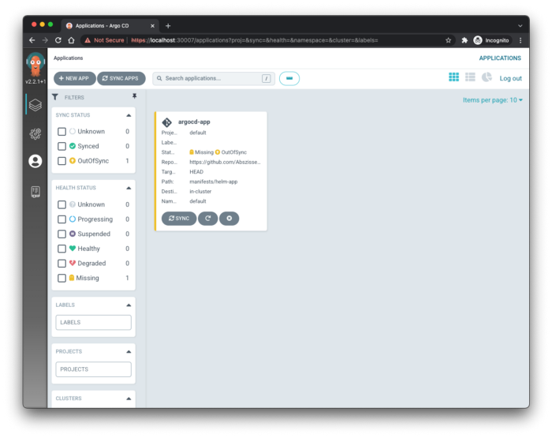
ArgoCD UI | Applications Overview
Clicking on the application tile, you will see the application detail view. Here you can already notice that ArgoCD tells you that it expects a namespace, service, and a deployment resource based on the Helm chart, at least if you take the one from my demo repository. But none of them are available yet, because we have prevented automatic synchronization in our manfiests/argo/argocd-app.yaml.

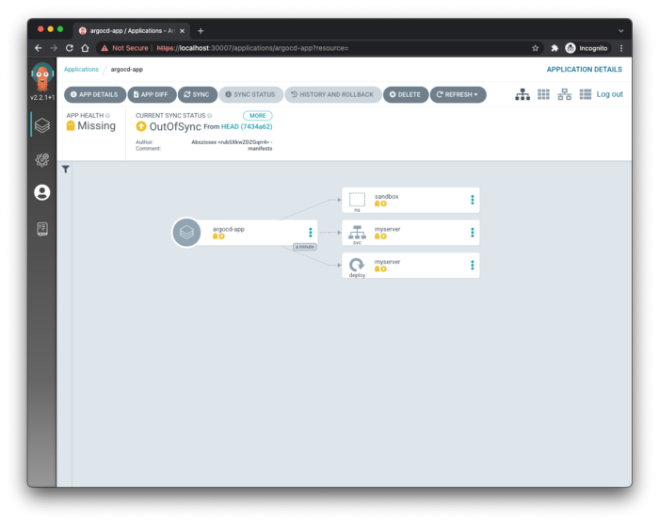
ArgoCD UI | Application Detail View
To make ArgoCD create the resources, we can hit the SYNC button at the top, select the resources we want to sync on the right panel ( you should always select all of them), and then hit the SYNCHRONIZE button on the right panel as shown in the following image:

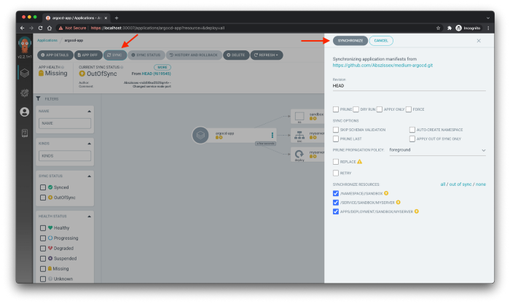
ArgoCD UI | Synchronizing resources
In a few seconds, you should see how ArgoCD spins up all the previously missing resources and goes into a "green state", indicating everything is synchronized.

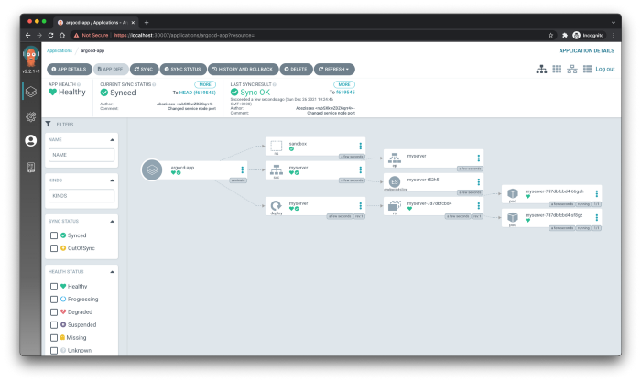
Argo CD UI | Synchronized resources

Changing your resources
Now let's change the replicas of our deployment in manifests/helm-app/templates/deployment.yaml from two to three replicas, commit and push the changes to the repository, and recheck our ArgoCD UI.
As you can see in the following image, ArgoCD tells us that our application is out of sync, and when we hit the MORE button, it will also provide us with the commit message of the newest change. In this case, it displays the commit message I wrote: "changed deployment replicas from 2 to 3"

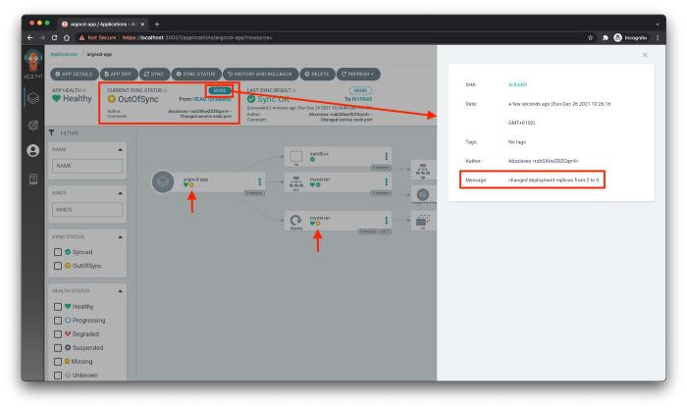
Argo CD UI | Out of sync
Of course, the git commit message is always an excellent indicator to see at first glance what has changed, as long as you and your teammates stick to proper git commit messages. But even if you do, you can't put everything into the git commit message. So the best way to find out what has changed from the current state compared to the new one is to check the actual diff of the changed resources.
The Argo CD UI provides a neat diff functionality out of the box. When you hit the APP DIFF button at the top left corner, ArgoCD will open another panel, displaying all the resources changed like GitHub or similar VSC providers.

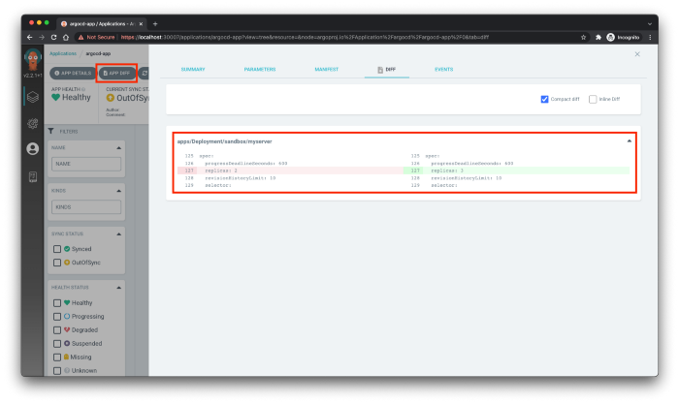
Argo CD UI | Diff of resources
When you are okay with the changes that the last commit introduced, you can hit the SYNC button again, as we did in the beginning, and ArgoCD will update your resources, become green, and you will see three instead of two replicas in the UI.

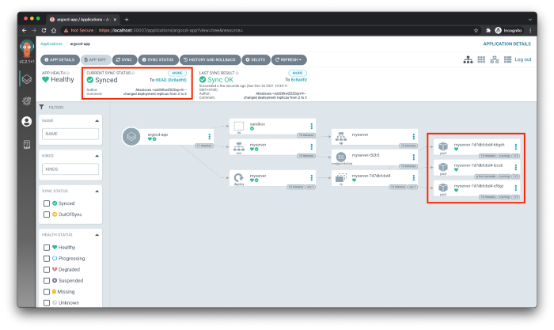
Argo CD UI | In sync again with three replicas

ArgoCD sync policy
Even though it's super easy to apply changes to your Kubernetes resources by manually hitting the sync button, the actual continuous deployment feeling where everything is updated automatically is still missing.
But don't worry. Of course, ArgoCD is also capable of applying your changes in an entirely automatic way.
As already mentioned in the beginning, ArgoCD Application resources provide a syncPolicy property to configure the automatic deployment behavior.
Now let's add some sync policy at the syncPolicy property to our existing ArgoCD Application.
The automated sync policy has three different properties that you can configure.
- prune — If true ArgoCD is allowed to prune resources during auto-syncing.
- allowEmpty — If true , allows deleting all application resources during automatic syncing.
- selfHeal — If true ArgoCD can automatically create and update resources based on the provided Helm chart.
If we would apply this changed ArgoCD application to our cluster again via kubectl and afterward do another change to our Helm chart again, e.g., reverting the replicas we changed previously, ArgoCD would automatically apply these changes without any human step.
One crucial point is that auto-sync doesn't work well with the ArgoCD rollback mechanism. This is expected because a rollback is usually a manual action, and auto-sync would immediately revert the rollback to sync with the repository again.

ArgoCD rollback
If you encounter an issue with your deployed resources and want to roll back to the previous state, it's as easy as it can get with ArgoCD.
To rollback, you only have to hit the HISTORY AND ROLLBACK button at the top of your application, select the commit you want to rollback to, and hit the Rollback button.

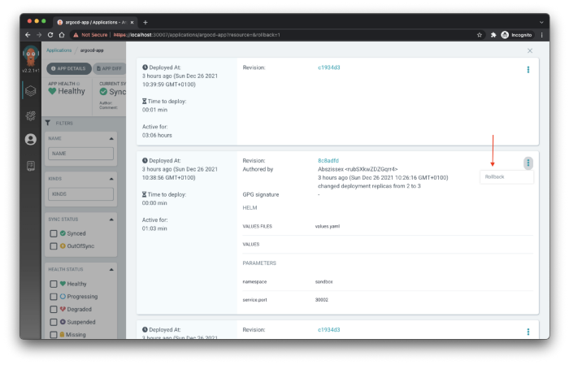
ArgoCD UI | Rollback
If you have some auto-sync policy enabled, the ArgoCD UI will show some popup, mentioning that you can't use auto-sync and rollback together and if auto-sync should be disabled. If you hit OK ArgoCD will remove the auto-sync policy from your ArgoCD Application and do the rollback.

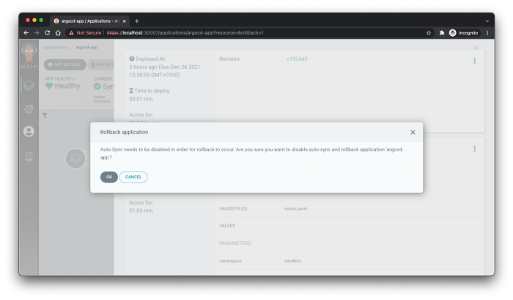
ArgoCD UI | Rollback auto-sync popup
But you need to be cautious now. If you would re-apply your ArgoCD Application manifest with the enabled auto-sync policy, ArgoCD would ensure that your application is in sync again and that your rollback would be reverted.

Summary
As you can see, the first steps with ArgoCD are pretty straightforward and not that difficult 🙂.
Hopefully, I picked up your interest in testing ArgoCD for your continuous deployment and could help you start quickly.
→ For more content, follow me on LinkedIn.

